# Program 1

CODE

<!DOCTYPE html>

<html>

<head>

<title>Learning HTML</title>

</head>

<center>

<h1>THis mY First web designing class instruction</h1>

<p> Hi mY naMe is mOhd dANisH kamraN </p>

<p> I am pursuing my BTech from NIET collage GREAter Noida</p>

<hr>

</center>

</html>

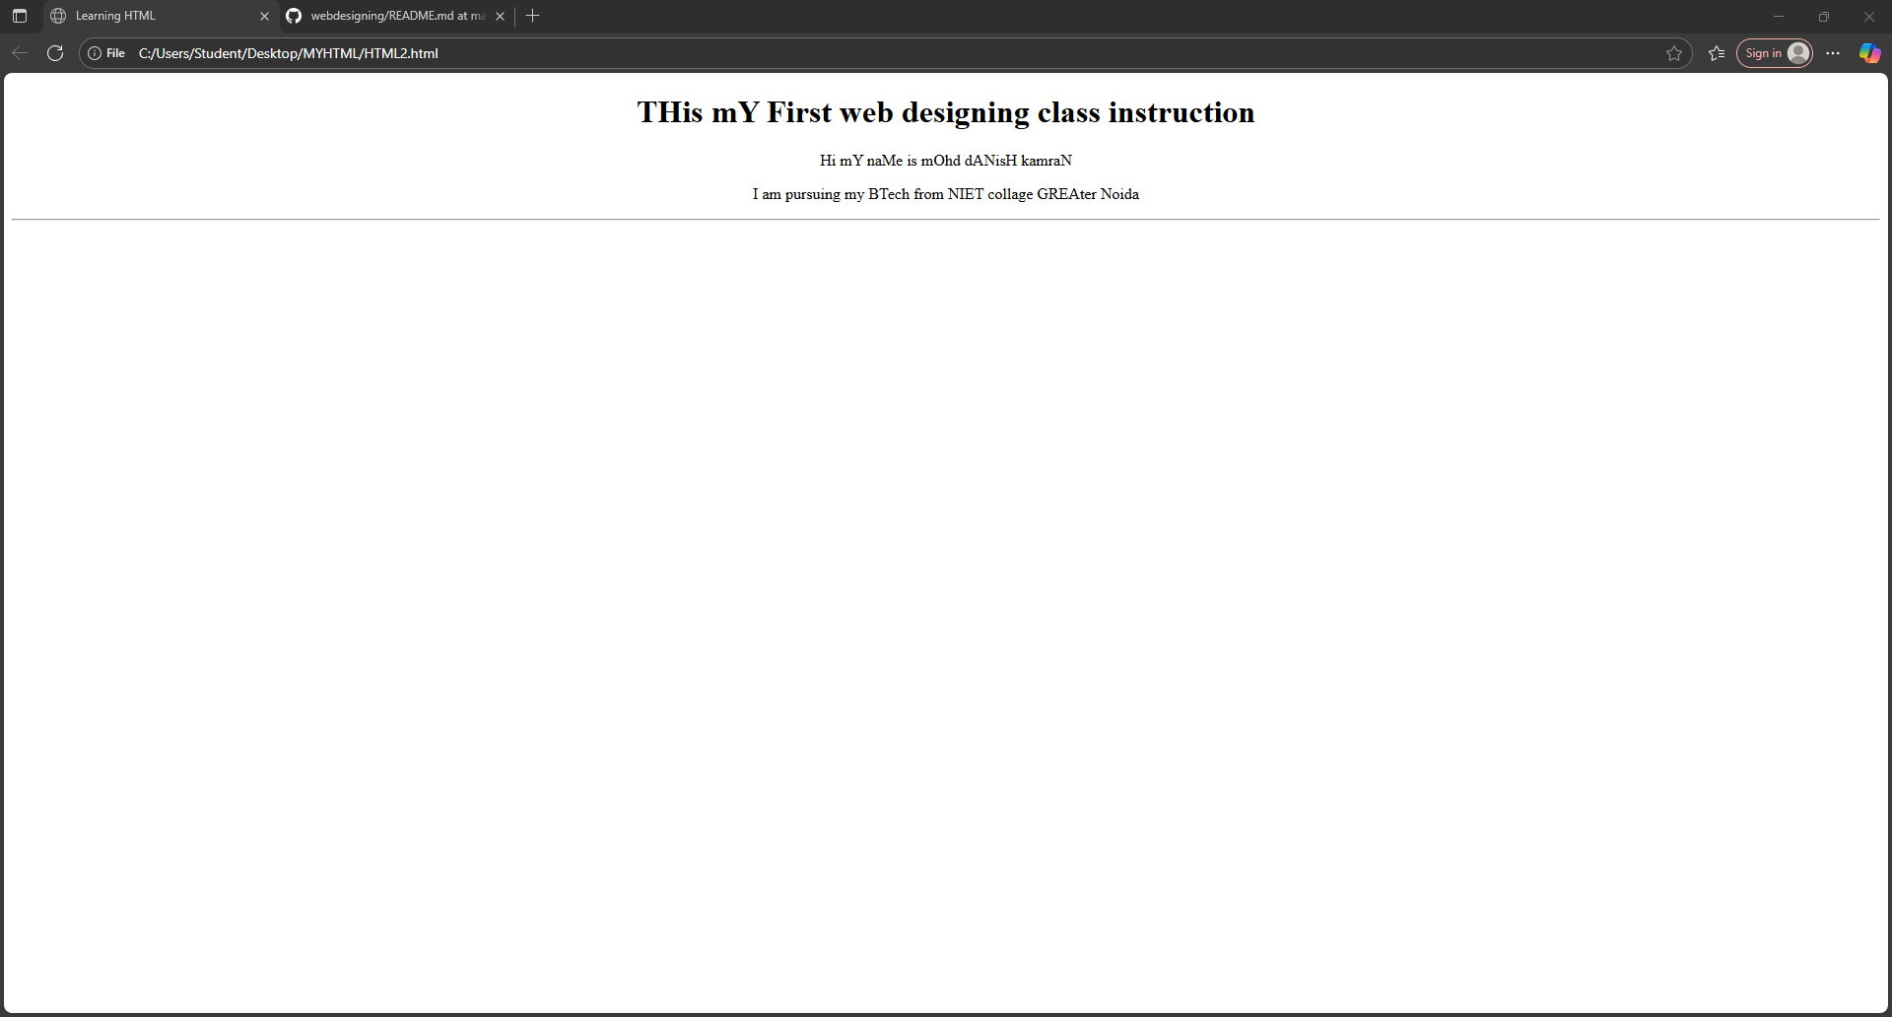 OUTPUT

UT